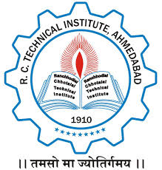

**A PROJECT REPORT ON**

BOOK MY BOOK

FOR THE PARTIAL FULFILMENT OF THE REQUIREMENT FOR THE

AWARD OF

DIPLOMA

IN

INFORMATION TECHNOLOGY

SUBMITTED BY

**BHIMANI RUTVIK (166400316007)**

**AMAN CHUHAN (166400316)**

**PAVAN DARJI (1664003160)**

**Department Of Information Technology**

R.C.TECHNICAL INSTITUTE, AHMEDABAD

2018-2019

**GUIDED BY Head of Department**

Mr. L.C.Ninama Mr.M.P.Parmar

Dept.of.Info.Tech. Dept.Of.Info.Tech

R.C.T.I, Ahmedabad R.C.T.I, Ahmedabad